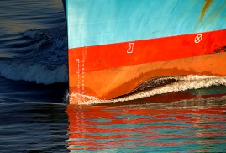
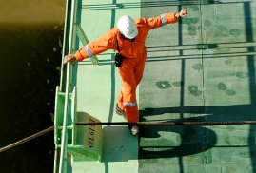
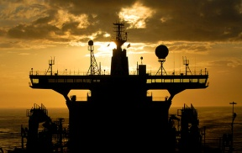
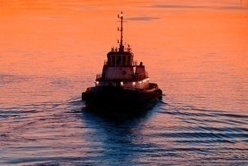
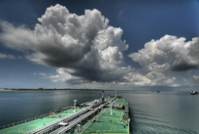

Press Release 7.1.10
New faces, services and equipment as Armada Marine Hydraulics continues to invest.
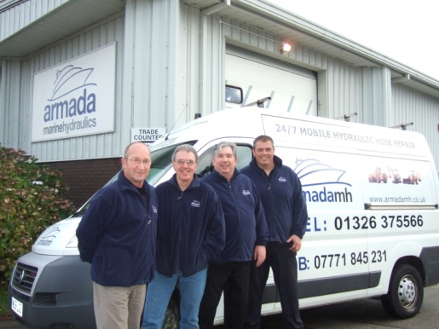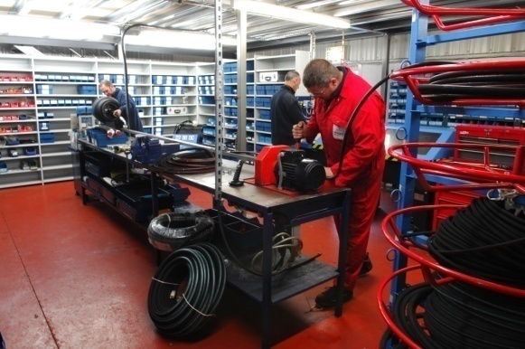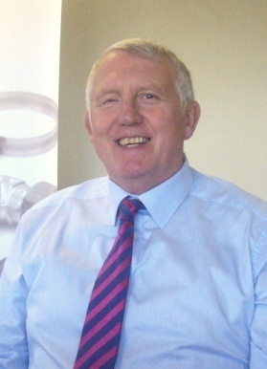
New faces at Armada with new mobile hose unit, new hose making bay, MD Martin Doney
Armada Marine Hydraulics Ltd continues to shrug off the effects of the credit crunch with new products and services, sales growth and continued investment in the business.
Despite the doom and gloom in some parts of the shipping industry, the Falmouth-based marine hydraulics specialist has seen year on year growth, including throughout the tricky last 12 months. Managing Director, Martin Doney, believes the focus on investment and growth has helped Armada to power through the recession.
Investment in the company’s factory and administration has included a brand new state of the art hydraulic hose making and testing bay, allowing certificated hoses to be produced to top international standards and a brand new van housing a mobile hose unit to enable Armada to respond to customers’ needs on-site throughout the Southwest. IT has had a complete overhaul too, with new web-based systems to allow engineers remote access to the company’s databases, a radical overhaul of the Armada24 e-Commerce website and a total IT upgrade.
In parallel with these hardware investments, Martin has also been building his team up and over the last few months, after a lengthy search, has recruited four new members of staff to improve levels of design, technical sales support and engineering capacity. The company has also engaged commercial marine marketing specialists Quantum Marine Marketing Ltd to boost its marketing and business development capacity, with an initial focus on UK based shipowners and managers. Strong results are already showing in the form of multiple engineering contracts worldwide.
“The overall effect”, Martin says “has been to absolutely reinvigorate the company. We now have the team I have been looking for, the facilities we have always wanted and the support systems we need in order to give our customers even better service. The results have come in at every step of the way. In the midst of a tough time for businesses generally, I am excited to say that Armada is still growing and is in the strongest position it could possibly hope to be in to capitalise on the recovery when it comes”.

Useful Links:
www.armadamh.co.uk
www.armada24.co.uk
www.quantummarketing.co.uk

This article is available to download from the Press section of Quantum’s website, including relevant high-resolution images. All copyright remains the property of Quantum Marine Marketing Ltd and use of this information is subject to a proof being supplied and approved by us.

